# Project report

By Jesper Bertelsen, AU-ID: au689481

Indholdsfortegnelse

Project report 1

Introduction 2

Implementation 2

The proposed design, n = 1 2

Assumptions 2

Parameters 2

My build 3

Observation 3

The inductors. 3

The capacitors. 5

The diodes. 6

Conclusion 7

The proposed design, n = 2 7

My build 8

Gain 8

Observed gain 9

Conclusion 10

Discussion 10

## Introduction

DC-DC converters are becoming popular nowadays because of electrical Vehicles. Optimizing the converters is essential to secure faster charging speeds, making it more lucrative for everyone to buy an electrical vehicle.

Doing this report I will be simulating converter designs made from a group of scientists and replicate some of their observations.

## Implementation

### The proposed design, n = 1

The proposed design of the non isolated dc-dc converter in the article achieves higher voltage gain than the conventional dc-dc converter.

The design:

#### Assumptions

From the article we get to know, that some assumptions are made for the proposed converter design.

The converter is in a steady state, so is constant.

are large, and therefore, their voltage in each switching period remains unchanged.

All switches and diodes are ideal.

#### Et billede, der indeholder tekst, skærmbillede, Font/skrifttype, nummer/tal Automatisk genereret beskrivelseParameters

Where the one I’m simulating is the Discrete Conductive Mode (DCM).

I am not using the other values, which is why my simulations are gonna differ from the publishers observations.

#### My build

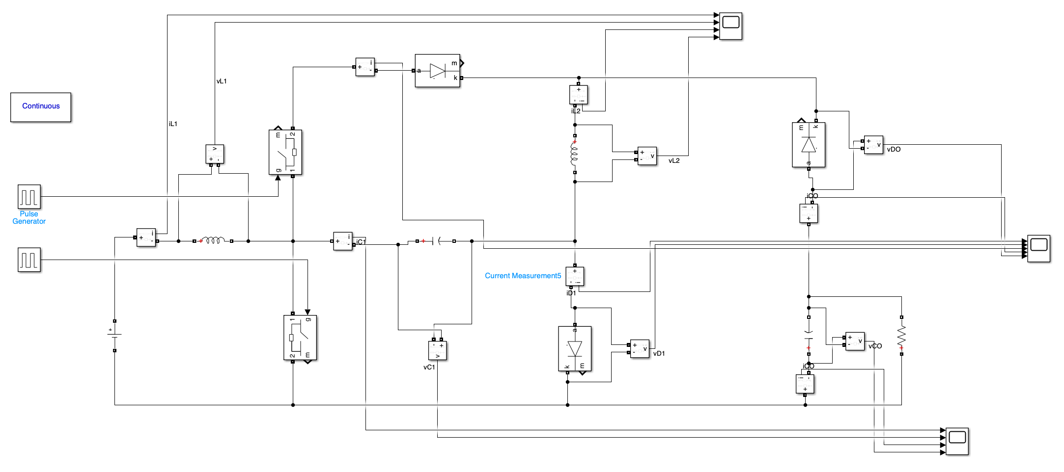

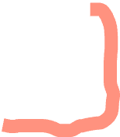

#### Observation

##### The inductors.

After about 7,75ms my converter stabilizes.



Zooming in I then compare:

The publishers observations: My observations:



Comparing these I find that my design differs a little to the publishers design.   
About the observations in L2 it seems as my design is phase shiftet compared to the publishers observations.

Applying 180° phase shift to L2:

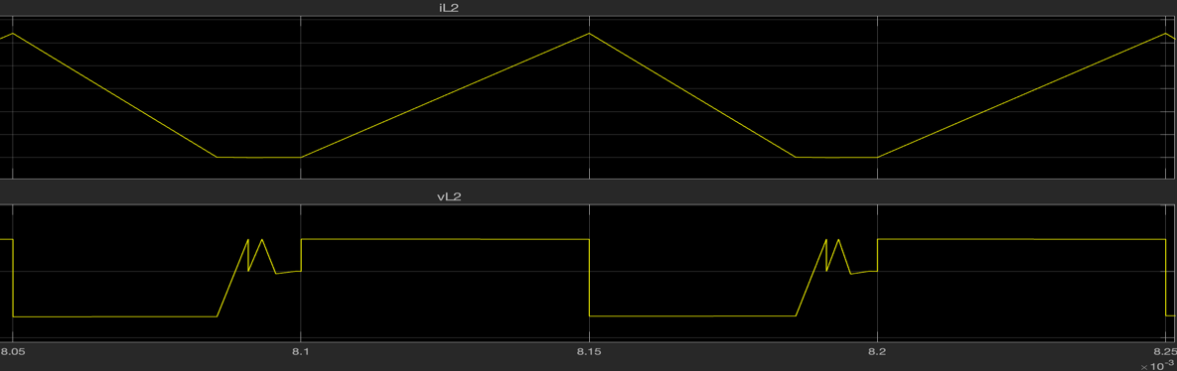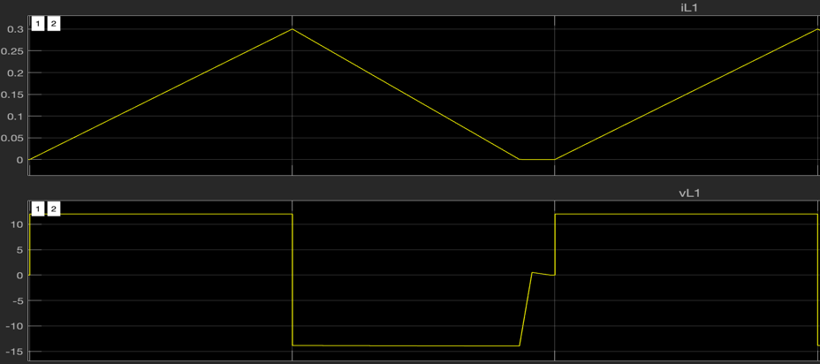

Now it looks more like the publishers observations.

I don’t know how come this is. But I knew that my observations were gonna differ from the publishers observations.

##### The capacitors.

My design makes the capacitors settle at about 8ms.

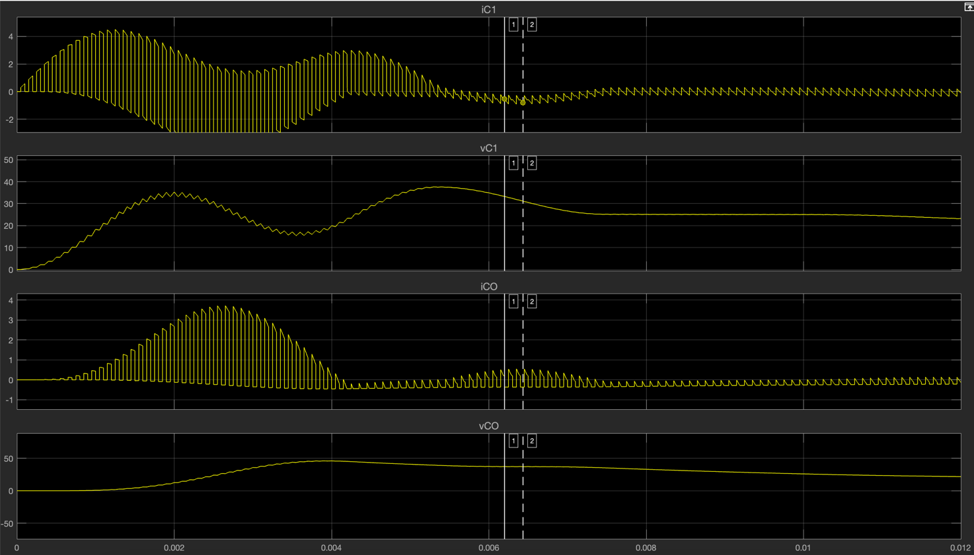

Zooming in to get a comparison.

The publishers observations: My observations:

Looking at the comparisons, the only commondivider is the . The other observations differs a lot. My voltage across the capacitor looks to be inverted and time reversed. Making it flip upside down, and horizontally.

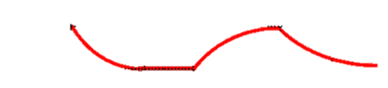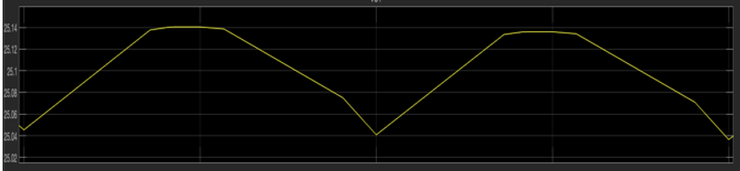

The voltage across it doesn’t seem periodic but rather converging to zero.

##### The diodes.

The design seems to be settled at arround . The other results have been around 8.



I therefore use 8 as this will make my observations more constant.



So with I see that, the characteristics are there. The publishers observe a more gradual increasing as I do. I still have the little bend at

Again I see a correlation where are phase shifted 180° compared to the observations of the publishers:

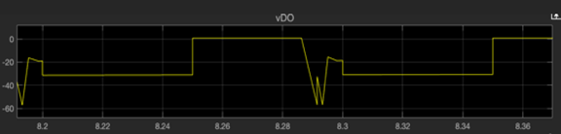



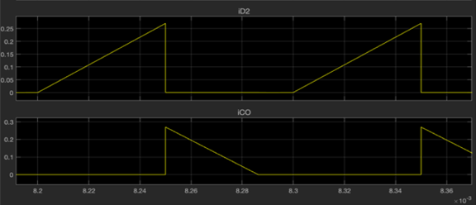



#### Conclusion

My design setup differs from the publishers setup, but the true conclusion comes, when I look at if the gain still can be described by their factors.

### The proposed design, n = 2



#### My build

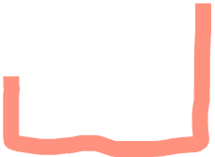

Not knowing about the new inductor, capacitance values I just set it equal to the L2, C1 as the middle part was in the n = 1 design.

### Gain

From the article I know that the gain value should be close to:

Where D is the duty cycle.

And for

Knowing this, and with my duty cycle of 0,5 I should suspect

#### Observed gain

*Proposed design*

I was expecting 4 but got less than half of that.

It seems as so my design settles at

:

When trying to simulate the model, I get the following error:

As the inductors are in series:

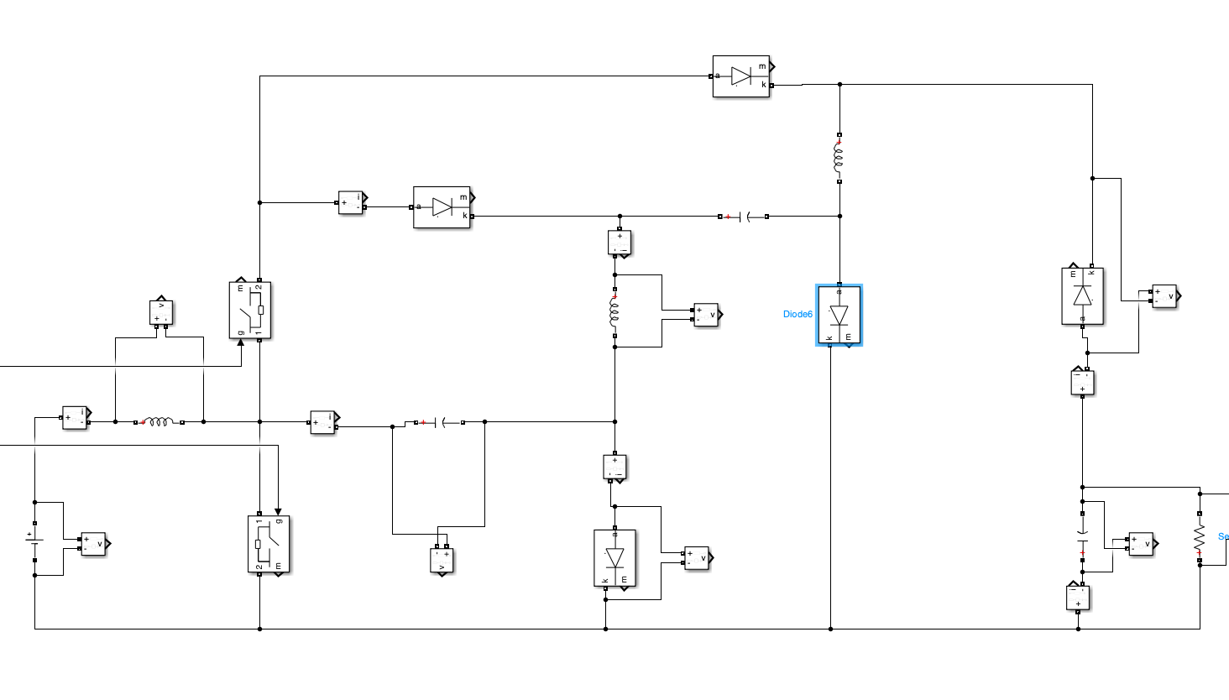



I don’t see the problem with that, but it might just have something to do with the Simscape software…

Unable to simulate the design because of the error, I will do my conclusions with the results of the stage design.

## Conclusion

The circuit does seem to have a gain. I was given equations for suspected gains and couldn’t achieve the same result. I achieved a 1,75 times gain with a duty cycle of 50%, when I was expecting 4 times gain. I could simulate the stage design because of an error, probably due to some simscape logic. I did however achieve a steady state for the V0, which was one of the assumptions made by the scientists.

## Discussion

I went into the schematics knowing that my design would differ as to the publishers, as I didn’t have the same models as them, and therefore didn’t use all the parameters as they did. The replica of the design may have looked the same as the publishers design, If I were to have all the same models as them.